VR_Room

VR_Room Sim now accepts the following variables via “input.csv” file:

* Position and rotation of Oculus camera
* Position and rotation of “findable” object
* Textures
  + Pick from a prebuilt list
    - Currently contains White, Black, Checkered and Vertical Stripes
  + Accepts 3 different inputs: Floor, Ceiling, and Walls
* Angle of the walls
* If the Offset screen is active (true/false)
* Position and rotation of offset camera
* Ability to invert the X, Y, and Z rotations individually of the Offset camera in relation to how the Oculus rotates

VR_Room will export the following into a “output.csv” file

* Time elapsed since Sim started
* Rotation of Oculus as (X,Y,Z)

Example Images:

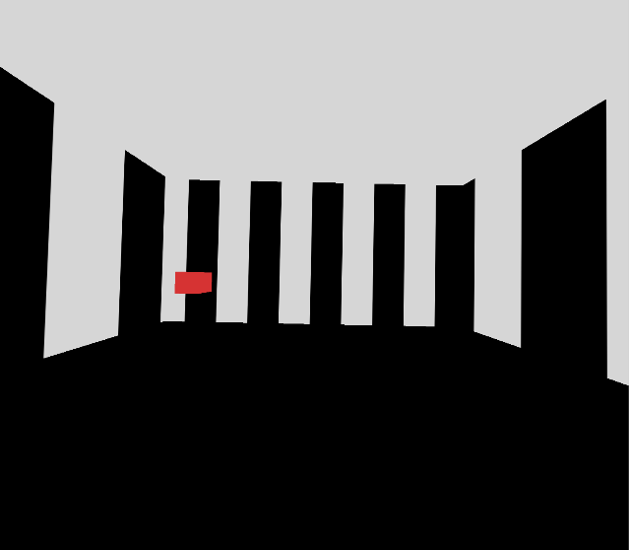

Above: Lined walls with black floor and white ceiling. No wall rotation.

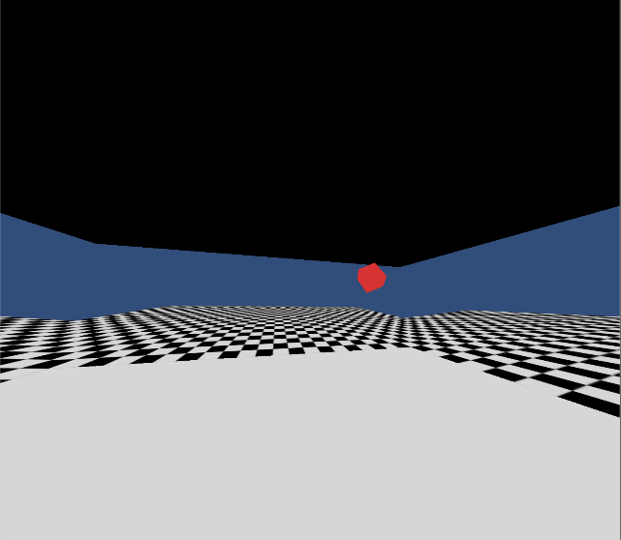

Above: White floor with black ceiling and checkered walls. Walls rotated 85 degrees down. Object also moved and rotated.